Problem:
Using just basic geometry prove that: a·a’=b·b’+c·c’

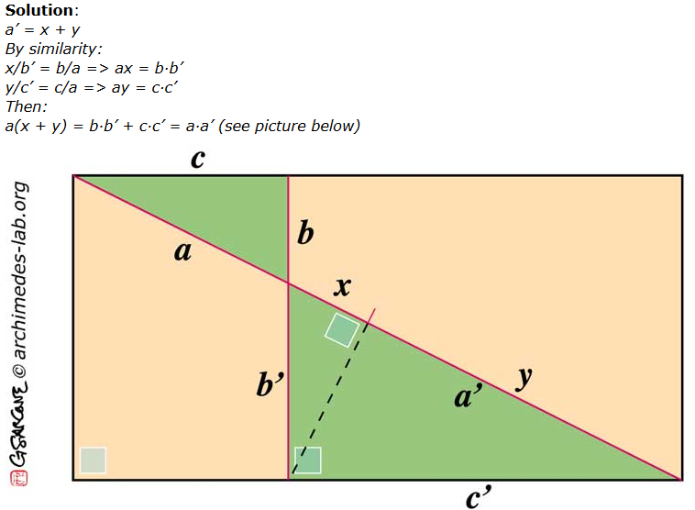

Quiz:
Who has the lowest career batting average among players with 3,000 hits.
- Cal Ripken
- Rickey Henderson
- Carl Yastrzemski
- Eddie Murray

